Ex:No:19
TRIGGER

Aim:
To implement trigger in MySQL.

Program 1 :
Create a trigger in MySQL to log the changes of the STUDENT table with fields ID, Name and Email. Also create a new table named EMPLOYEES_AUDIT to keep the changes of the employee table. Create a BEFORE UPDATE trigger that is invoked before a change is made to the employees table.
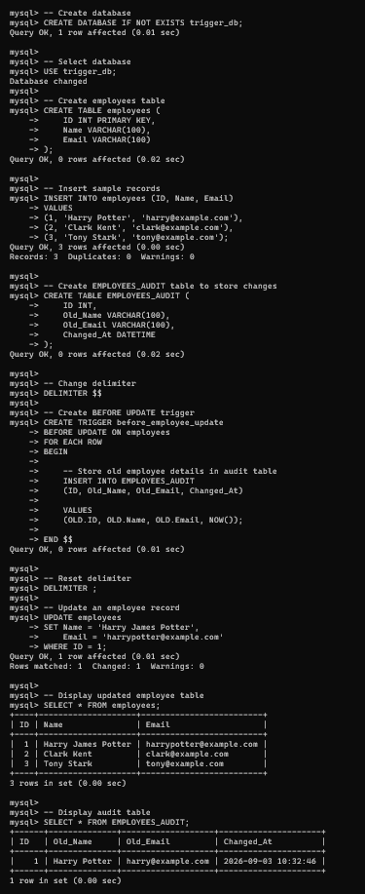
RESULT: Thus the trigger is executed successfully.

